Electronics Documentation

1. Electronics Block Diagram
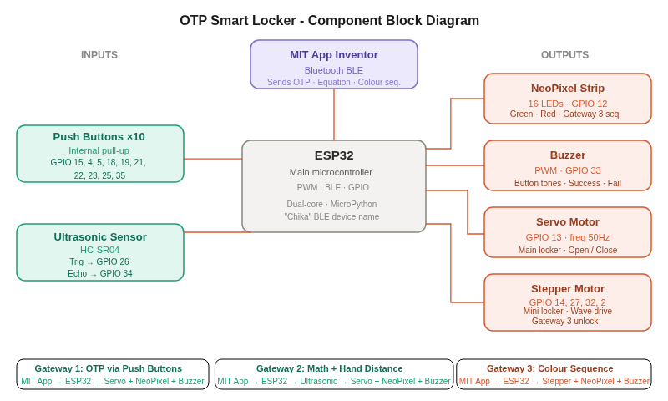

2. Components Table
Component | Quantity | Purpose | Justification
INPUT
Pushbuttons | 10 | Physical keypad for OTP entry. | Provides tactile, physical interaction for the user to input the generated code.
Ultrasound Sensor  [HC-SR04] | 1 | Measures hand distance between the user and the safe [math equation] | Allows for touchless interaction and precise distance measurements (evaluated with a +/- 2.0cm tolerance).
PROCESSING
ESP32 | 1 | - Receives input (from BLE, pushbuttons and HC-SR04)  - Receives and executes system logic  - Controls Hardware (servo, stepper, NeoPixel, buzzer) | Required for built-in BLE capabilities to communicate with the app, plus the GPIO pins
OUTPUT
Servo motor | 1 | Operates the main sliding door mechanism | - Provides exact positional control (110 to 70 degrees) to reliably open and close the main door.  - Most preferable as our main door had a linear sliding mechanism (using a scissor structure).  - A quick momentum was needed and its small size made it easier to position it below the door.
Stepper motor | 1 | Operates the mini locker mechanism | - Wave-drive stepping allows for accurate rotational control.  - Preferable as its light (was required to be stuck on the wall).  - Anti-clockwise, clockwise rotation.
NeoPixel | 1 | Visual feedback and custom color sequences  - Correct sequence – green  - Wrong sequence – red  - Mini locker – multicolour | Requires only one data pin to control multiple LEDs, saving crucial GPIO pins on the ESP32.
Buzzer | 1 | Auditory feedback  - Different frequency for each pushbutton when OTP is entered.  - Correct sequence  - Wrong sequence  - Opening of main locker and mini locker | Crucial for accessibility and user feedback
POWER
SMPS Adaptor | 1 | Provides voltage to power module | To convert wall AC power into a stable, high-current 5V DC power source for the entire circuit.
Power Module | 1 | - Distributes power to high-draw components  - Provides voltage to NeoPixel, servo and stepper motor | The ESP32 cannot safely output enough current to drive the motors and NeoPixel simultaneously; external power prevents brownouts.
Motor Driver | 1 | Controls the stepper motor | To adjust the voltage of the coils within the stepper motor.
EXTRA
Jumper wires  (Male and Female) | Many. | Connection of all the components | Makes tighter connections, easier to tape up as compared to normal wire.
10k ohm resistor | 1 | External pull-up resistor for Pin 35 (pushbutton) | Pin 35 is input-only and lacks an internal pull-up resistor; required to prevent floating signals and "ghost typing."

